

American International University-Bangladesh (AIUB)
Department of Computer Science
Faculty of Science & Technology (FST)

Pharmacy Management System
Semester: Fall 25-26

Group: |  | Section: O
SL | Student Name | Student ID
1 | Md Afrazur Rahman | 23-50041-1
2 | Kazi Sanjida Islam | 23-52300-2
3 | Rehabul Tanveer Fahim | 23-51324-1
4 | Akramuz-Zaman Fahid | 23-51142-1
5 | Md Asif Rayhan | 23-50428-1

Table of Contents

1. Project Proposal xx
1.1 Background to the Problem xx
1.2 Selection of Process Model xx
2. Software Requirements Specification (SRS) / PRD xx
2.1 Scopes and Features xx
2.2 User Story Table xx
2.3 Requirements Traceability Matrix xx
2.3.1 Functional Requirements xx
2.3.2 Non-Functional Requirements xx
3. Software Design xx
3.1 System Deisgn xx
3.2 UI Deisgn using Figma xx
4. Git Workflow xx
5. Software Testing xx
6. Conclusion xx

1. PROJECT PROPOSAL

  - Background to the Problem
The healthcare sector in Bangladesh faces significant challenges in pharmacy management, particularly in inventory control, prescription tracking, and regulatory compliance. Traditional pharmacy operations rely heavily on manual record-keeping, leading to medication errors, stock shortages, expired drug wastage, and inefficient patient service.
Pharmacies struggle with:
- Manual inventory tracking causing stockouts or overstocking
- Difficulty in tracking prescription history and patient allergies
- Lack of integration with doctor prescriptions and insurance providers
- Inefficient billing and sales reporting
- Regulatory compliance challenges for controlled substances
- Limited patient engagement and medication adherence support
With the growing digital transformation in Bangladesh's healthcare sector, there is a clear need for an integrated Pharmacy Management System that automates operations, ensures medication safety, and improves patient care while maintaining regulatory compliance.

  - Selection of Process Model:Dynamic Systems Development Method (DSDM)

Why DSDM for MediCare+
- Healthcare Criticality: Pharmacy systems require high reliability and accuracy. DSDM's quality-first approach ensures medication safety.
- Regulatory Compliance: DSDM's iterative testing allows continuous validation against healthcare regulations.
- Stakeholder Collaboration: Pharmacists, doctors, and patients must be involved throughout development.
- Time-Sensitive Delivery: Pharmacy operations cannot afford delays, making DSDM's time-boxing essential.

DSDM Implementation Timeline
- Pre-Project (Week 1): Identify project scope and stakeholders
- Feasibility (Weeks 2-3): Technical and regulatory feasibility study
- Foundations (Weeks 4-6): Architecture design and compliance planning
- Evolutionary Development (Weeks 7-20): Iterative feature development
- Deployment (Weeks 21-22): Pilot deployment in selected pharmacies
- Post-Project (Weeks 23-24): Monitoring and optimization

2. SOFTWARE REQUIREMENTS SPECIFICATIONS (SRS) / PRODUCT REQUIREMENTS DOCUMENT (PRD)

2.1 Scopes and Features

Core Platform Features
- Dashboard - Real-time overview of pharmacy operations
- User Authentication - Role-based access (Admin, Pharmacist, Cashier)
- User Profile Management - Staff and patient profiles

Inventory Management Features
- Medicine Inventory - Stock management with expiry tracking
- Supplier Management - Vendor and purchase order management
- Stock Alert System - Low stock and expiry notifications
- Batch Tracking - Medicine batch and lot number tracking

Sales & Billing Features
- Point of Sale (POS) - Billing and invoice generation
- Prescription Management - Digital prescription handling
- Insurance Integration - Insurance claim processing
- Sales Reporting - Daily, weekly, monthly sales reports

Patient Management Features
- Patient Records - Medical history and allergy tracking
- Appointment Scheduling - Pharmacy consultation bookings
- Medication Reminders - SMS/email reminders for patients
- Loyalty Program - Customer rewards and discounts

Compliance & Reporting Features
- Regulatory Compliance - Audit trails for controlled substances
- Financial Reporting - Profit/loss, tax reports
- Analytics Dashboard - Business intelligence and insights

2.2 User Story Table

2.2 User Story Table – Pharmacy Management System
As a | I want to | So that | Acceptance Criteria
Pharmacist | Search medicine by name/type | I can quickly find medicines for customers | Search returns results in < 2 seconds
Pharmacist | Scan medicine barcode | I can quickly add items to bill | Barcode scanner integrates with POS
Patient | View prescription history | I can track my medication history | All past prescriptions visible
Admin | Generate inventory reports | I can make restocking decisions | Stock levels & expiry dates shown
Cashier | Process insurance claims | Patients can use their insurance | Insurance verification < 30 seconds
Patient | Receive refill reminders | I don't run out of essential medicines | SMS sent 3 days before refill due
Admin | Track controlled substances | I comply with regulations | Complete audit trail maintained
Supplier | View purchase orders online | I can prepare timely deliveries | All pending orders visible
Doctor | Send digital prescriptions | Patients get accurate medication | Prescription reaches pharmacy instantly
Pharmacist | Check drug interactions | I prevent harmful combinations | System alerts on potential interactions

2.3 Requirements Traceability Matrix

2.3.1 Functional Requirements

ID | Requirement Description
FR-1 | Dashboard
FR-1.1 | Show real-time sales metrics
FR-1.2 | Display low stock alerts
FR-1.3 | Show daily performance summary
FR-1.4 | Provide quick action buttons
FR-2 | User Authentication
FR-2.1 | Role-based login (Admin/Pharmacist/Cashier)
FR-2.2 | Two-factor authentication for admin
FR-2.3 | Session timeout after 15 minutes
FR-3 | Medicine Inventory
FR-3.1 | Add/edit/delete medicine records
FR-3.2 | Track stock quantity automatically
FR-3.3 | Set reorder levels for each medicine
FR-3.4 | Expiry date tracking and alerts
FR-4 | Point of Sale (POS)
FR-4.1 | Generate bills with GST calculation
FR-4.2 | Accept cash, card, mobile payments
FR-4.3 | Print/email receipts
FR-4.4 | Handle returns and refunds
FR-5 | Prescription Management
FR-5.1 | Upload digital prescriptions
FR-5.2 | Verify prescription validity
FR-5.3 | Track prescription fulfillment
FR-5.4 | Maintain prescription history
FR-6 | Patient Management
FR-6.1 | Create and update patient profiles
FR-6.2 | Record patient allergies
FR-6.3 | Track patient purchase history
FR-6.4 | Send medication reminders
FR-7 | Reporting
FR-7.1 | Generate sales reports
FR-7.2 | Create inventory reports
FR-7.3 | Export reports to PDF/Excel
FR-7.4 | Schedule automatic report generation

2.3.2 Non-Functional Requirements

ID | Requirement Description
NFR-1 | Performance
NFR-1.1 | System response time < 3 seconds
NFR-1.2 | Support 100+ concurrent users
NFR-1.3 | Handle 10,000+ medicine SKUs
NFR-2 | Security
NFR-2.1 | HIPAA/GDPR compliance for patient data
NFR-2.2 | Encrypted data transmission and storage
NFR-2.3 | Regular security audits and penetration testing
NFR-3 | Availability
NFR-3.1 | 99.9% system uptime
NFR-3.2 | Automated backup every 24 hours
NFR-3.3 | Disaster recovery within 4 hours
NFR-4 | Usability
NFR-4.1 | Intuitive interface with minimal training required
NFR-4.2 | Mobile-responsive design
NFR-4.3 | Bangla and English language support
NFR-5 | Compatibility
NFR-5.1 | Windows, macOS, and Linux compatibility
NFR-5.2 | Support for common barcode scanners
NFR-5.3 | Integration with popular payment gateways
NFR-6 | Scalability
NFR-6.1 | Support for multiple pharmacy branches
NFR-6.2 | Cloud-based deployment option
NFR-6.3 | Modular architecture for easy feature addition

3. SOFTWARE DESIGN
3.1 System Design:

Class Diagram
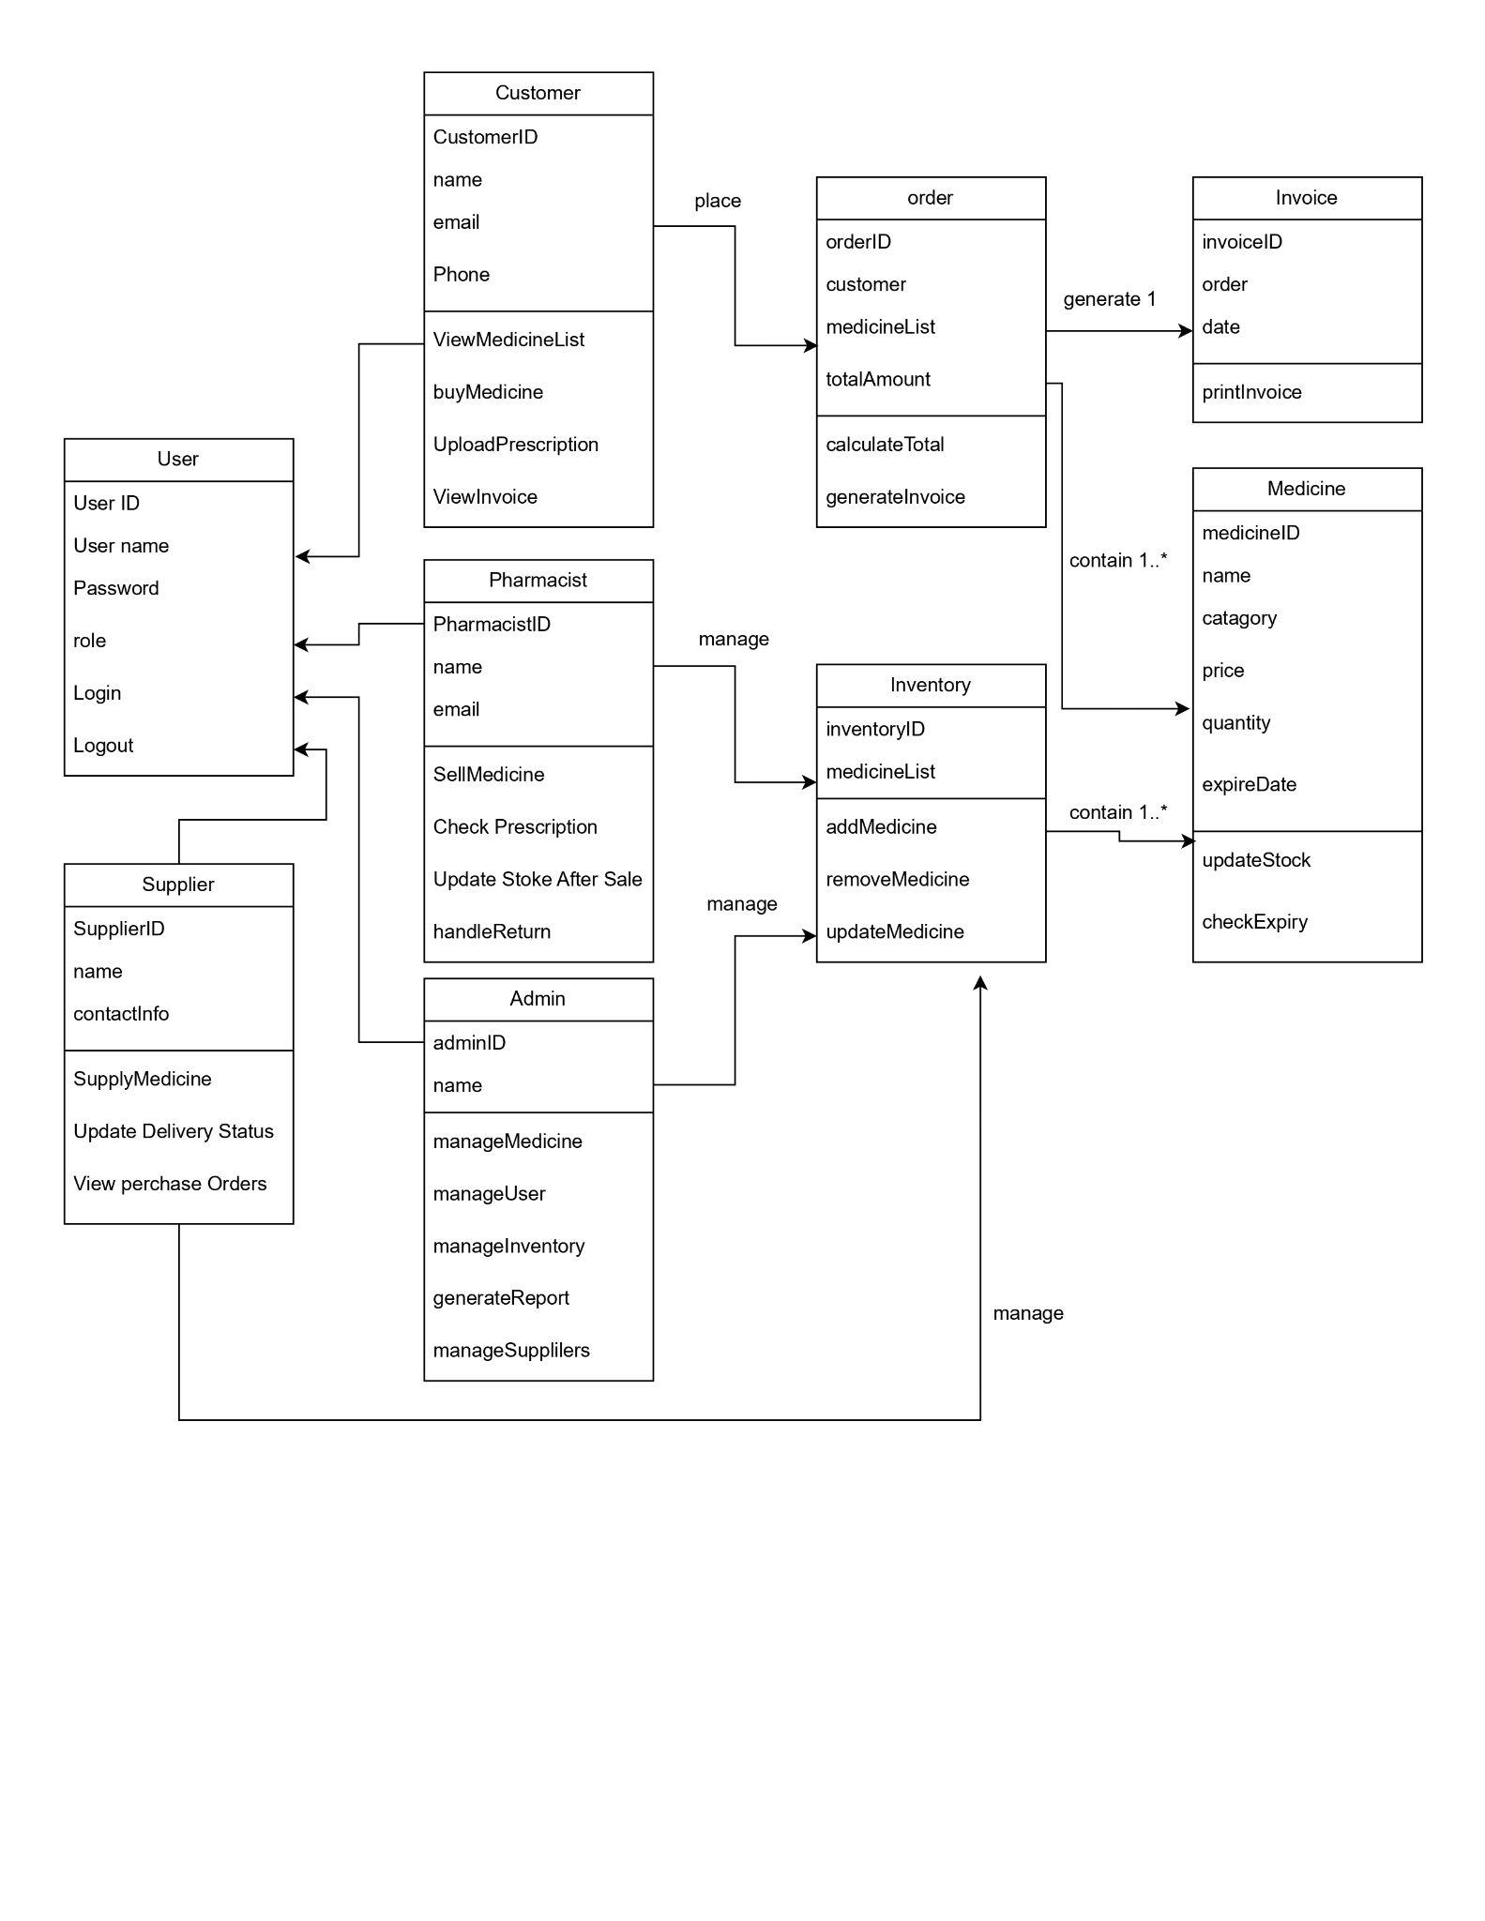
Use case Diagram
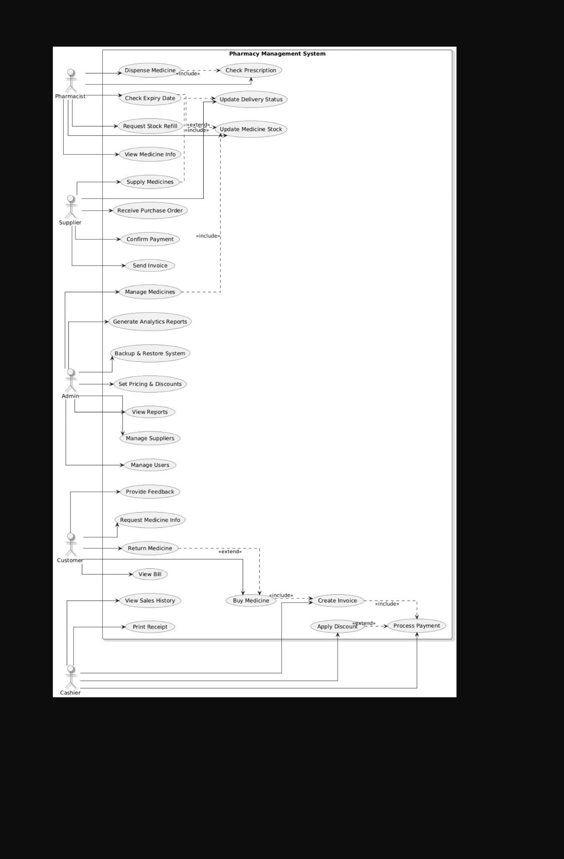

Activity daigram
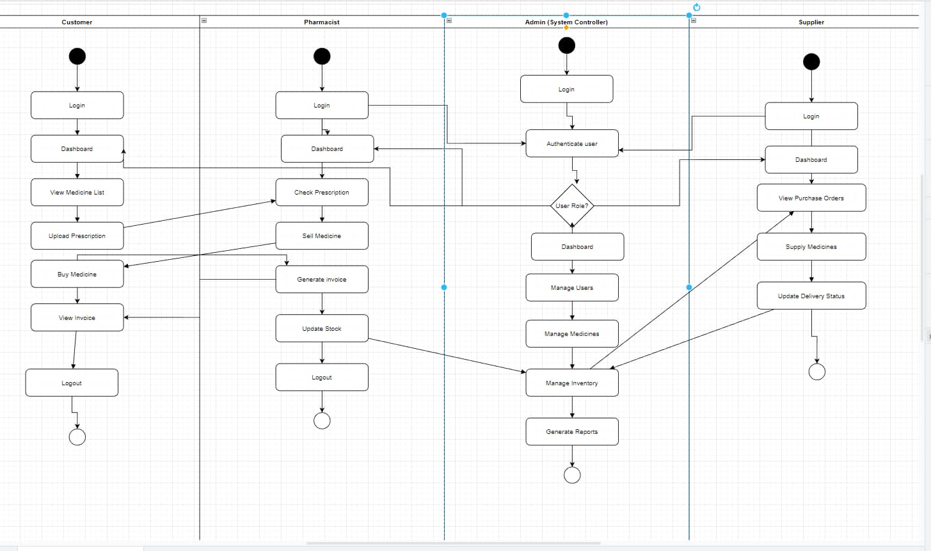

UI / Wireframe Design using Figma
Afraz – login + admin
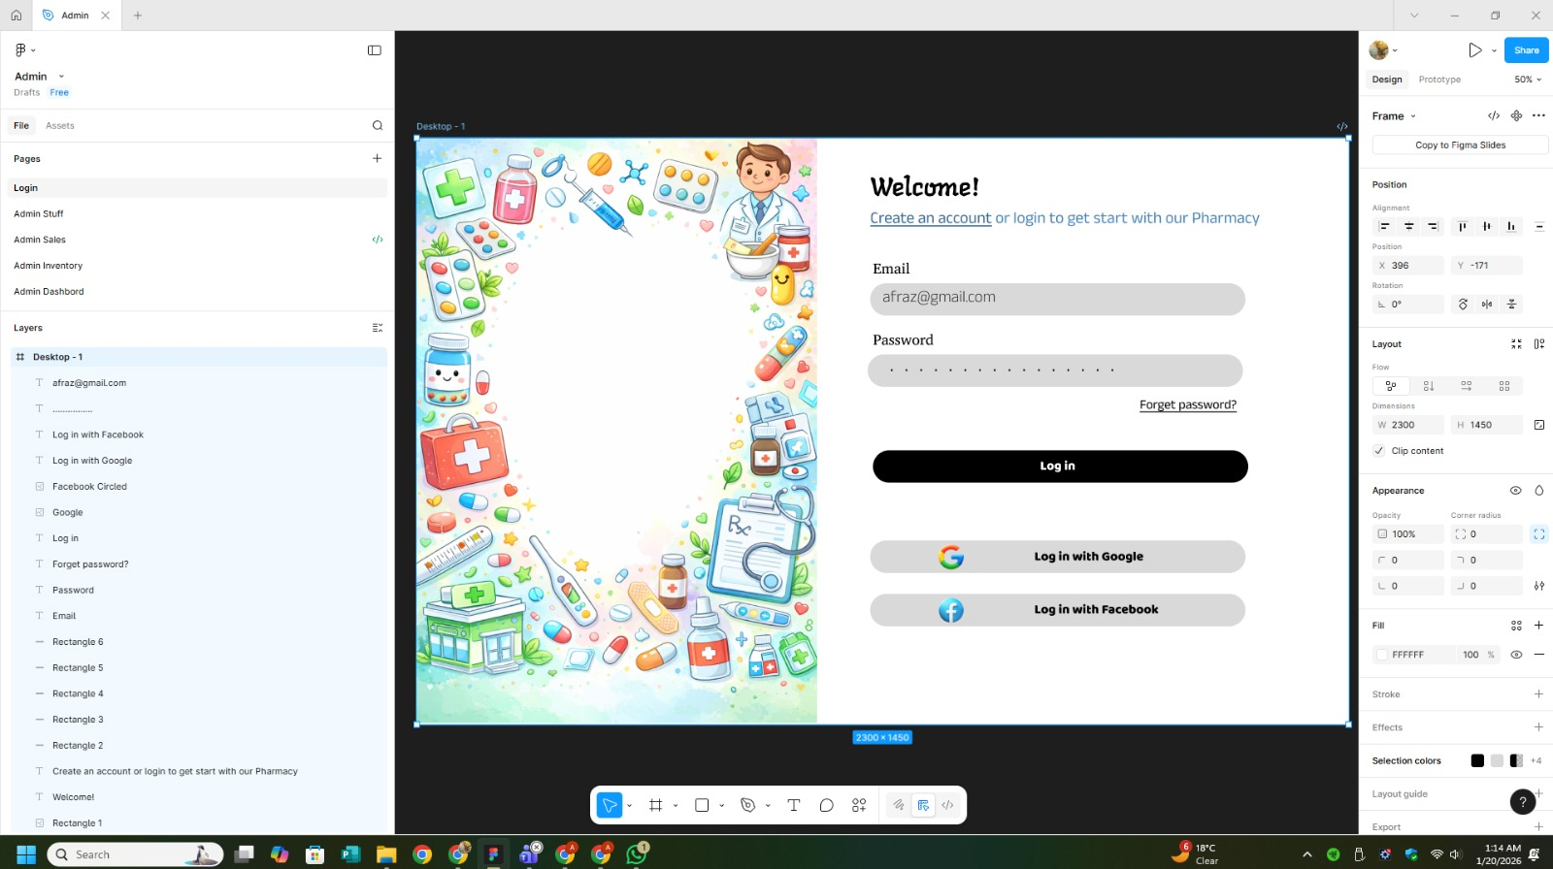

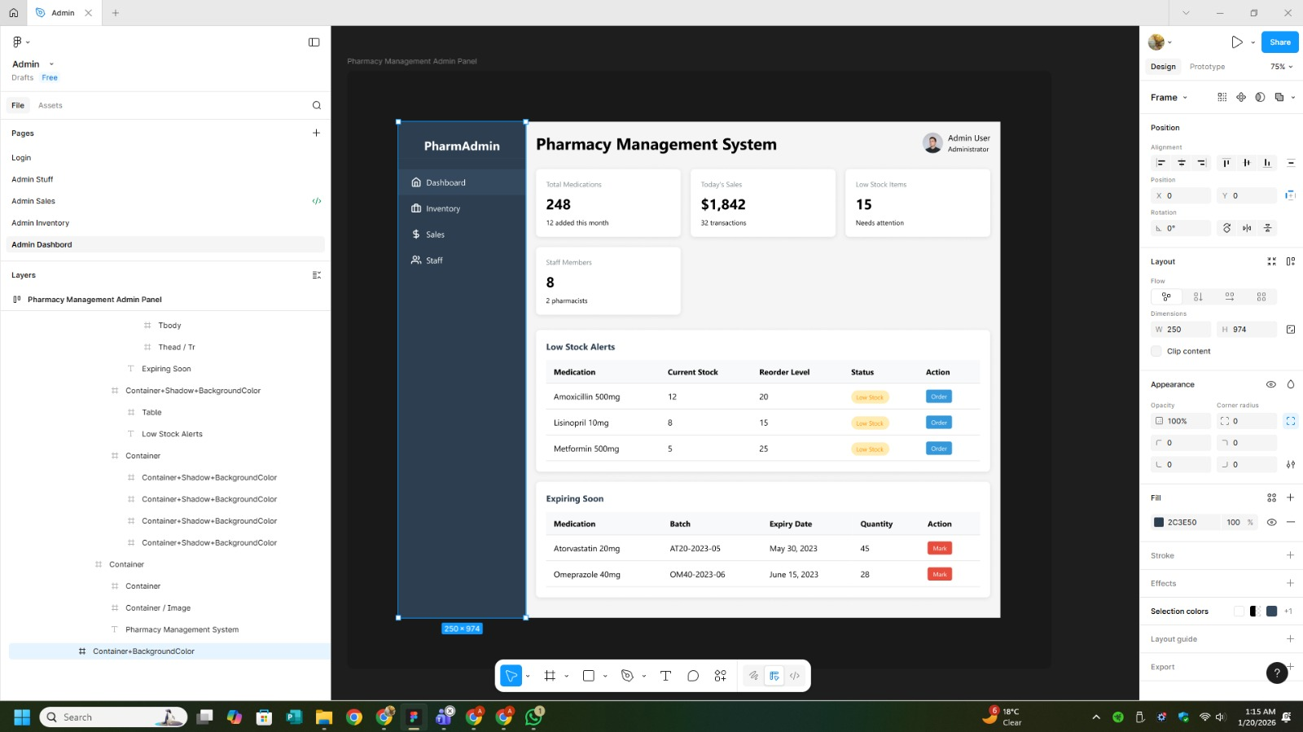

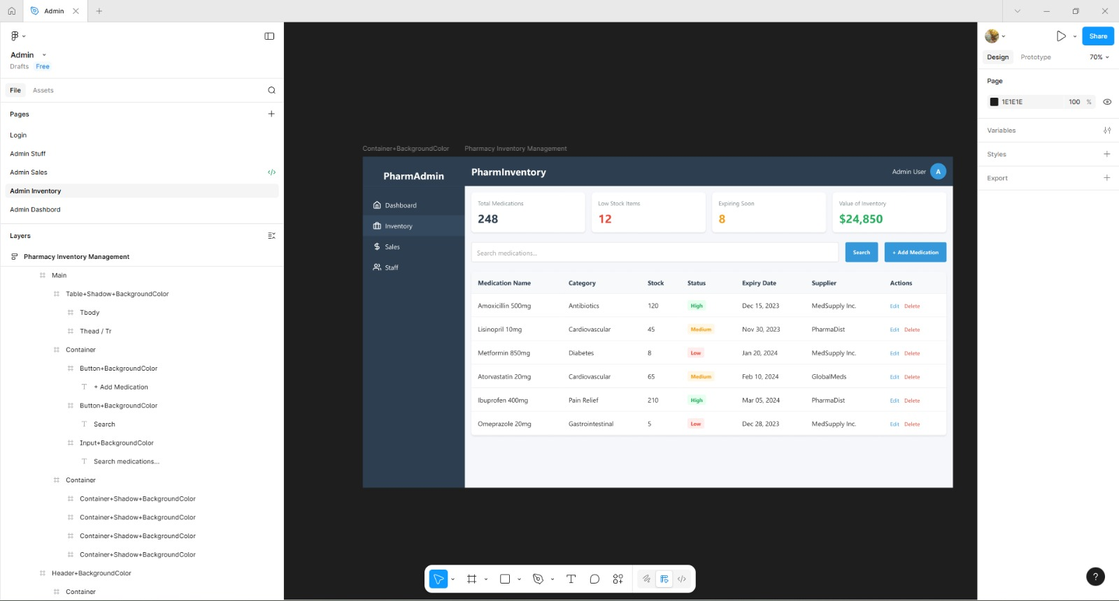

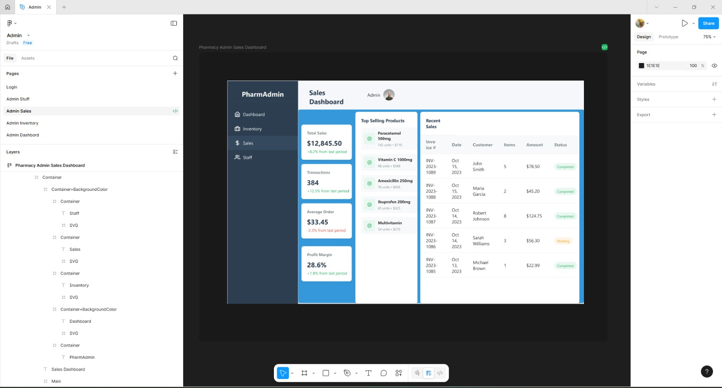

Sanjida-
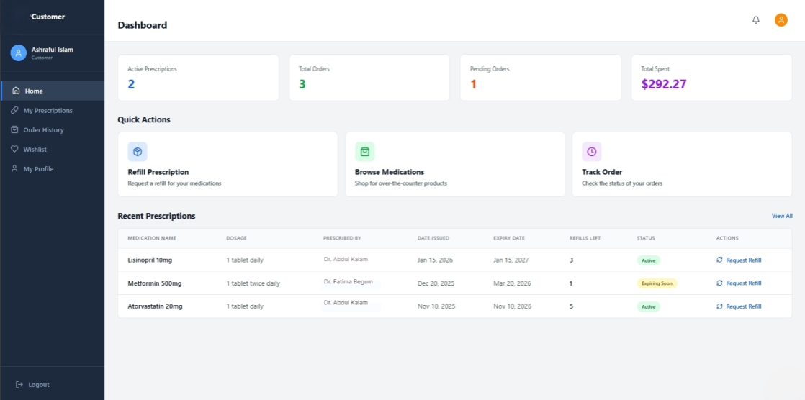

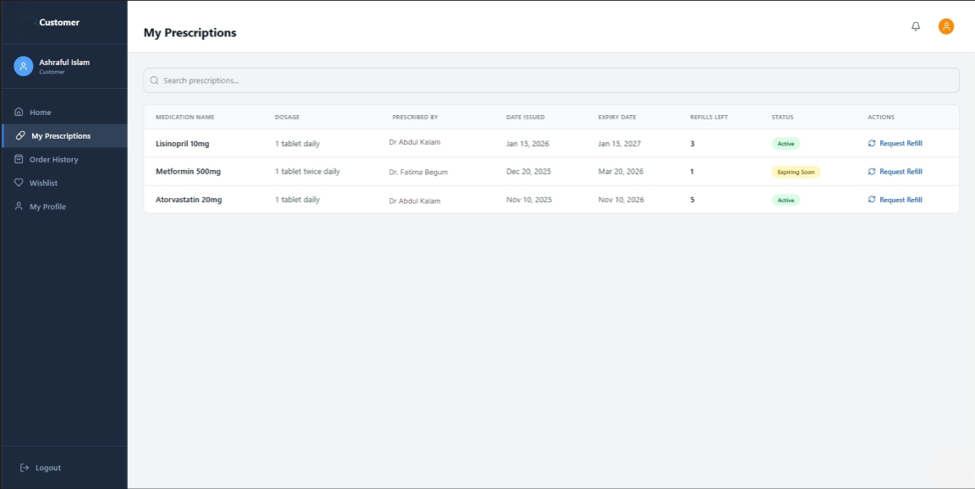

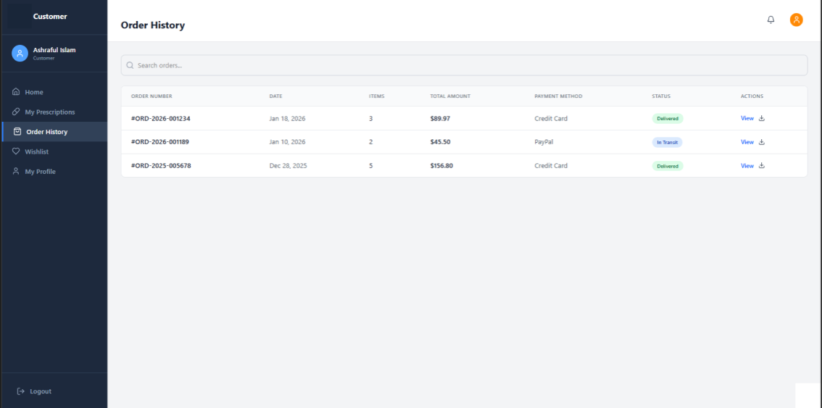
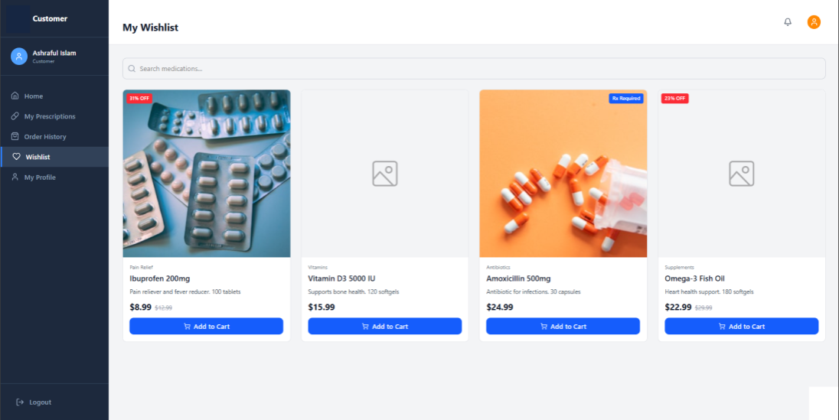
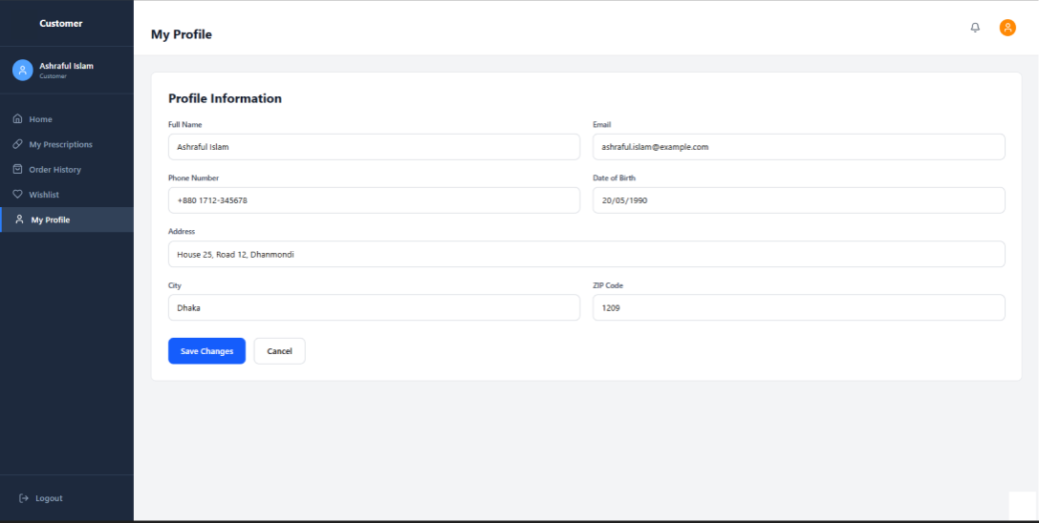

Fahid
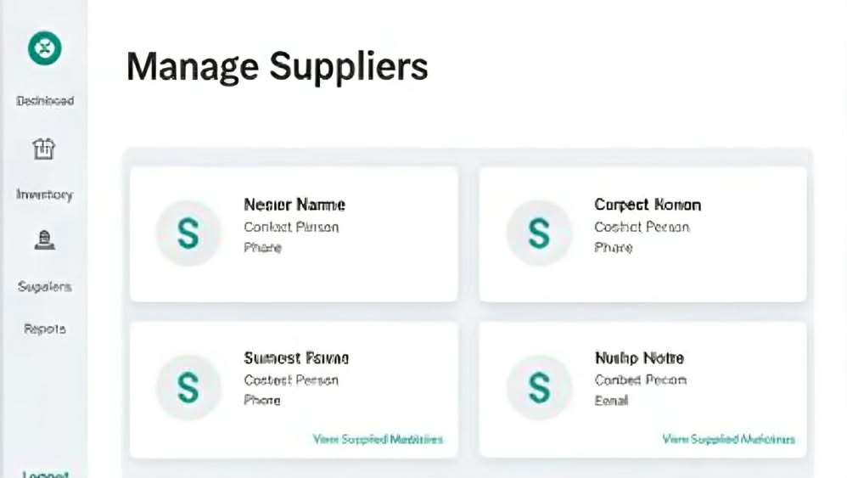

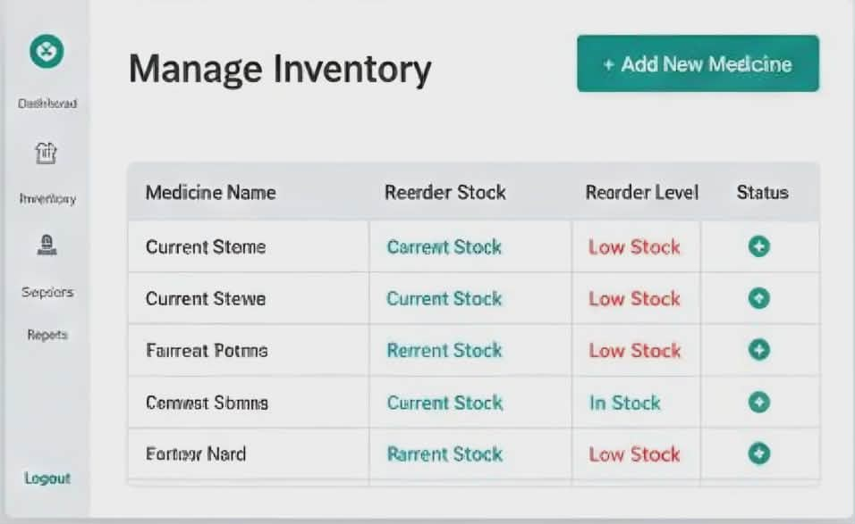

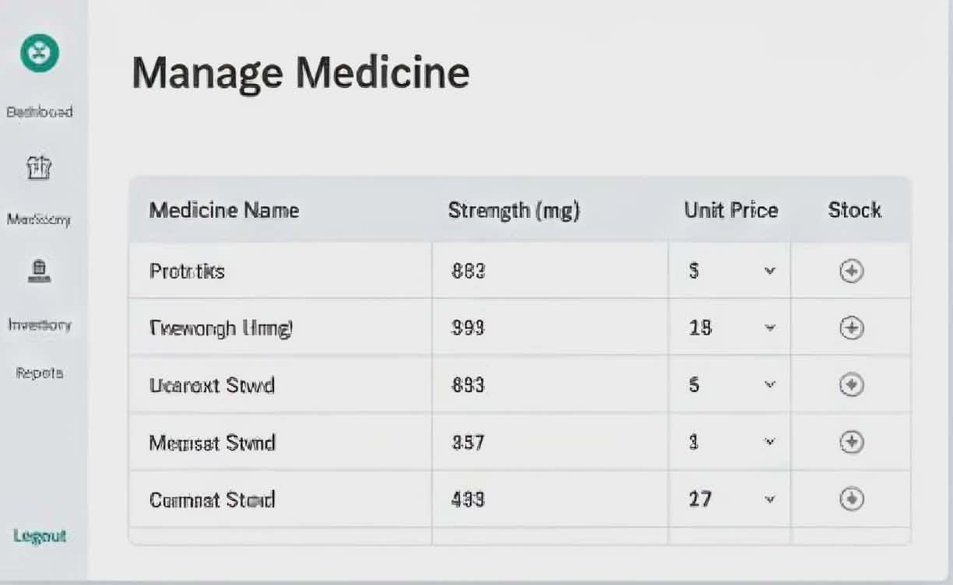

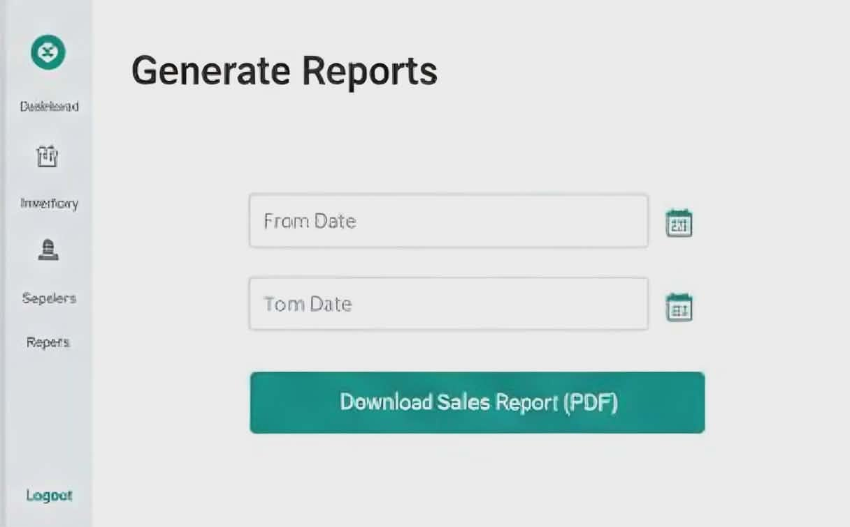

Fahim-
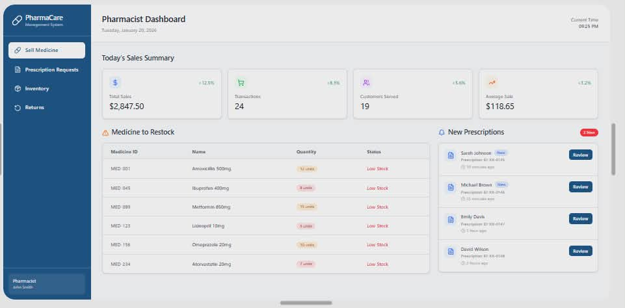
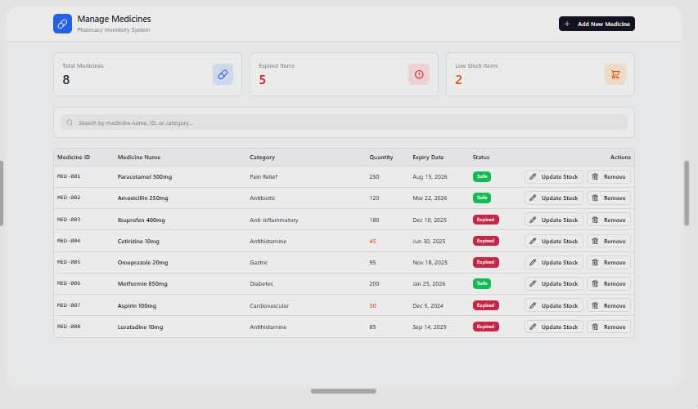

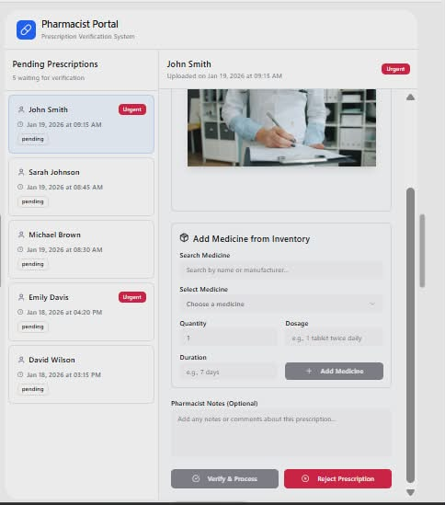
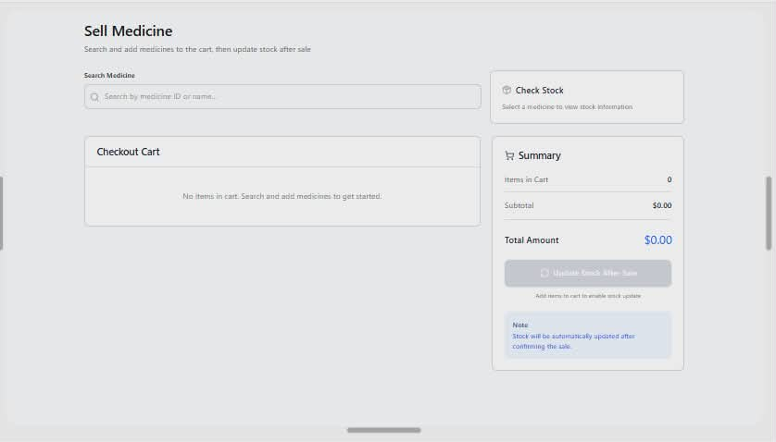

GIT WORKFLOW MD AFRAZUR RAHMAN
Creating feature branch
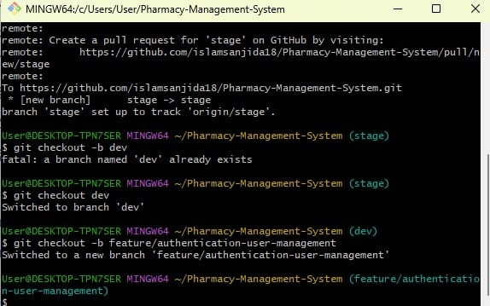
Editing PROJECT_FEATURES.md to simulate feature work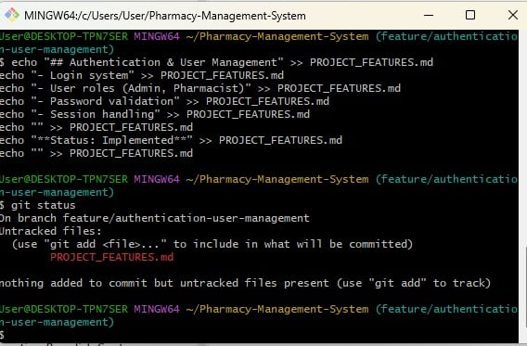
Adding file + committing
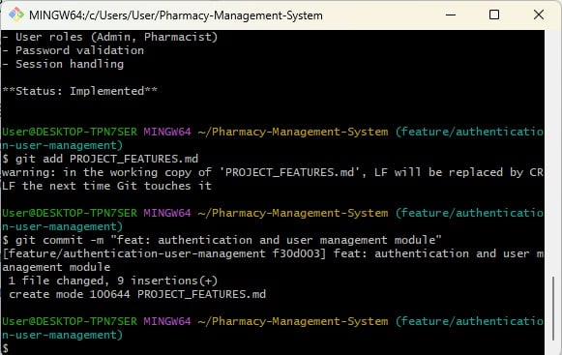
Pushing feature branch to GitHub
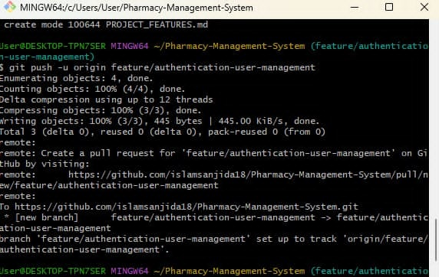

Fahid
Feature Branch Creation and Version Control
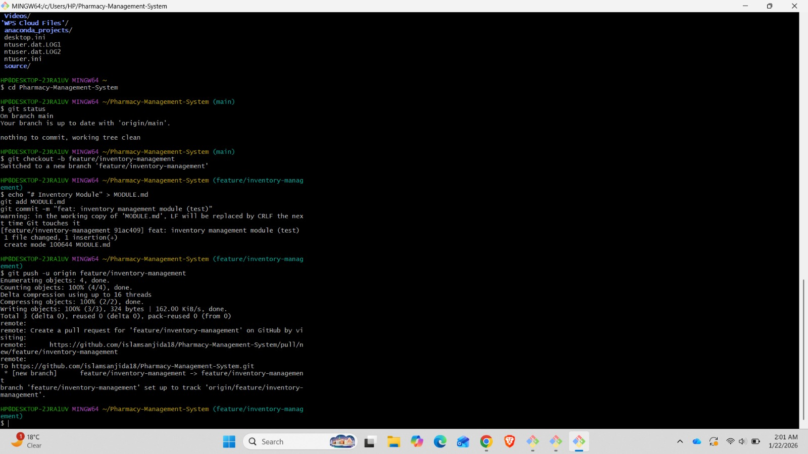

Repository Cloning and Local Environment Setup
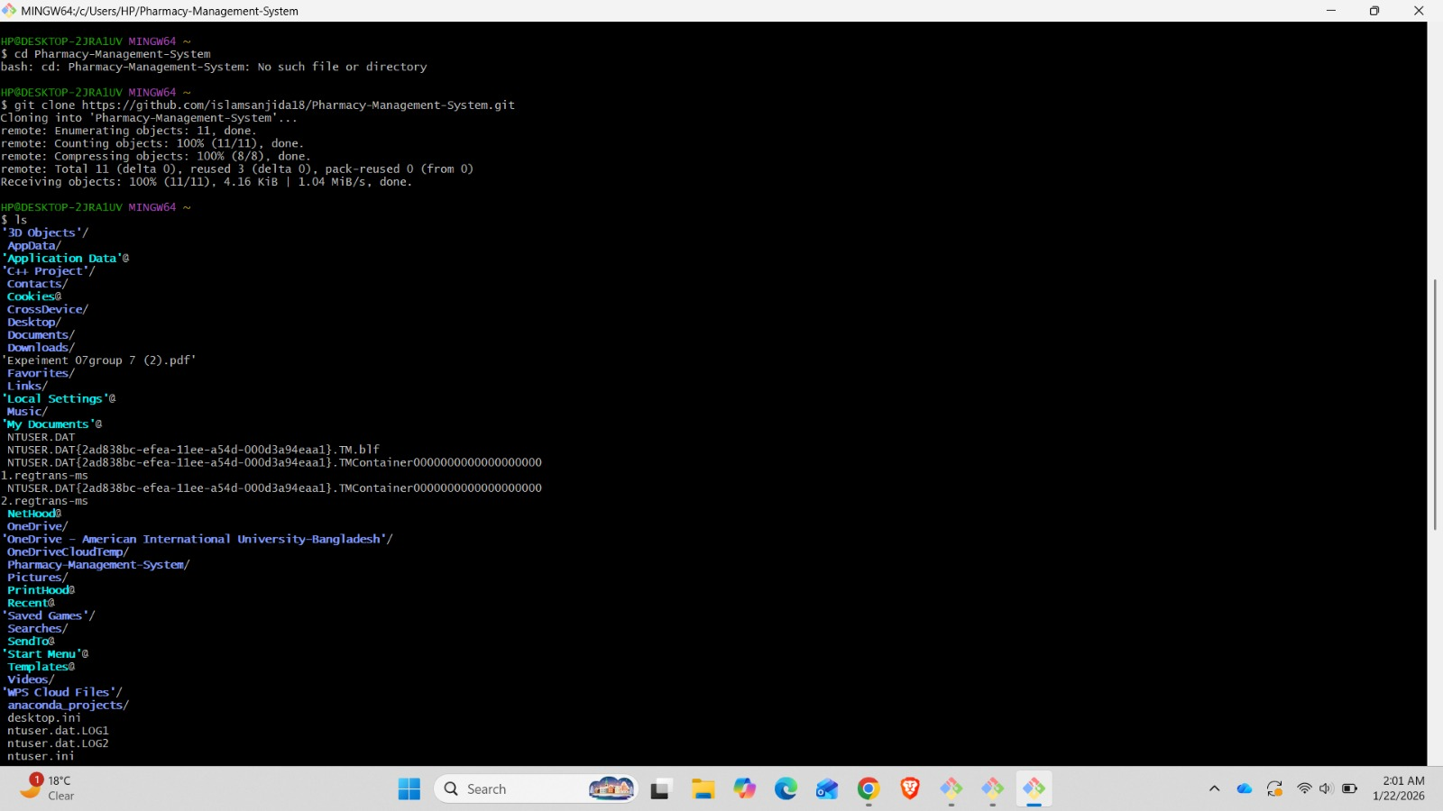

Git Configuration and Command Execution Awareness
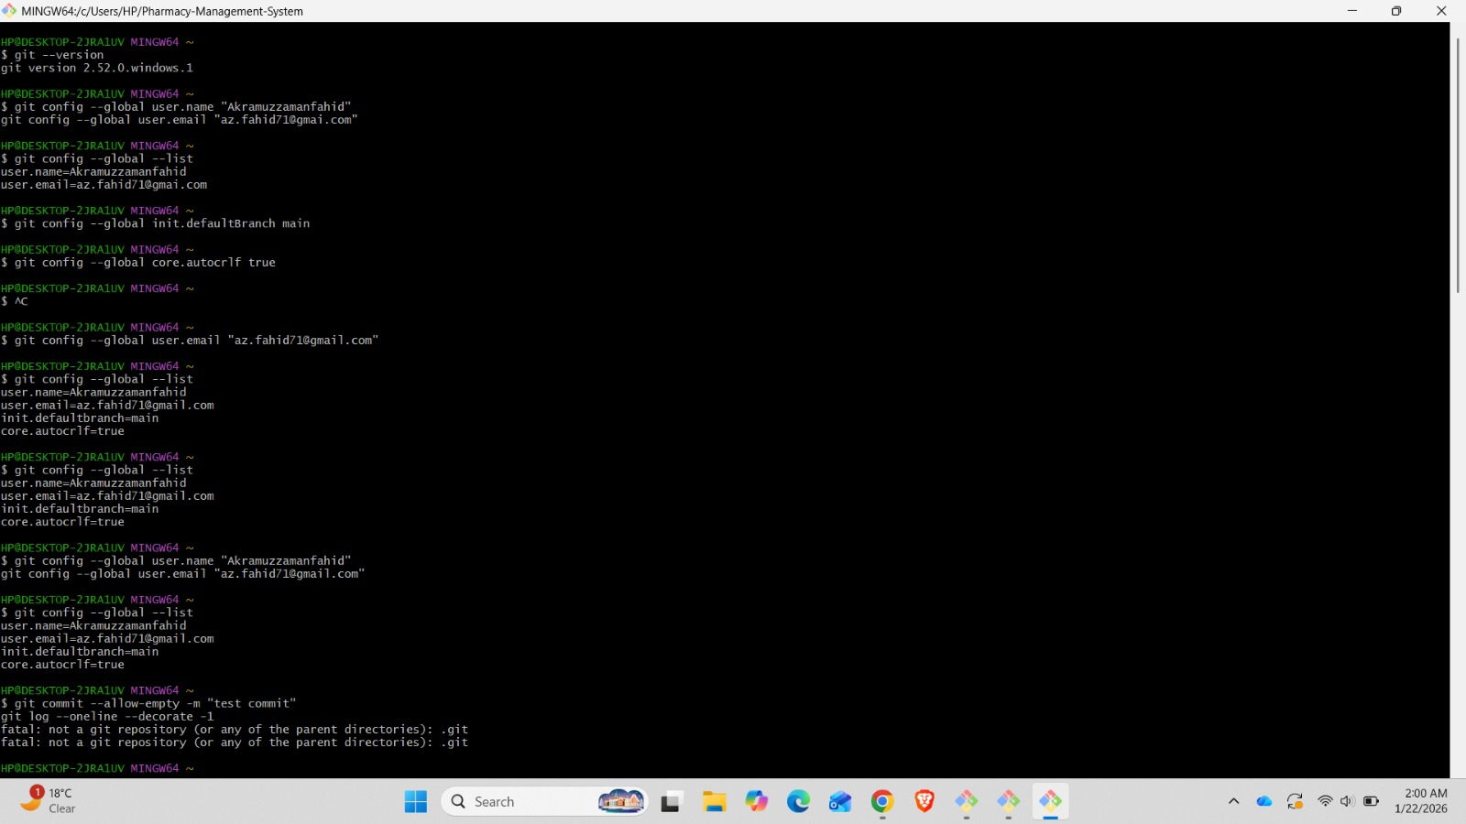
Fahim-
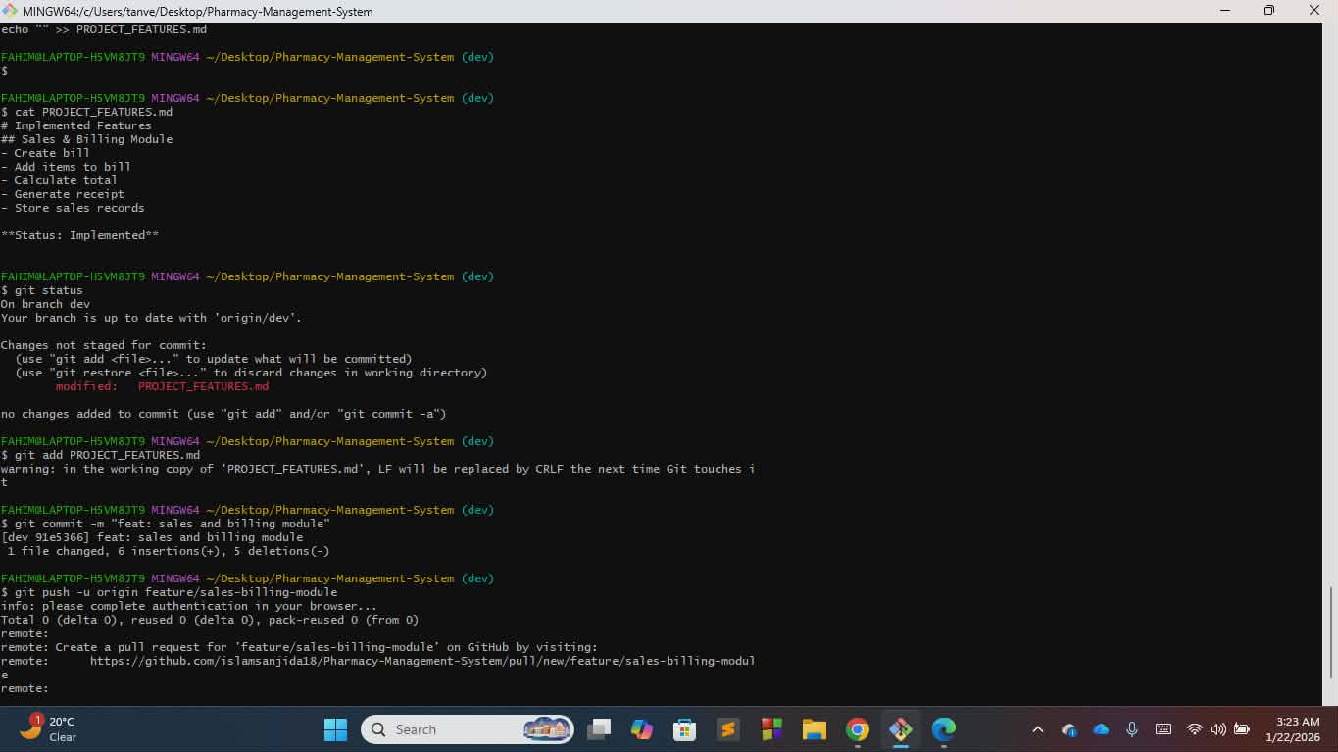
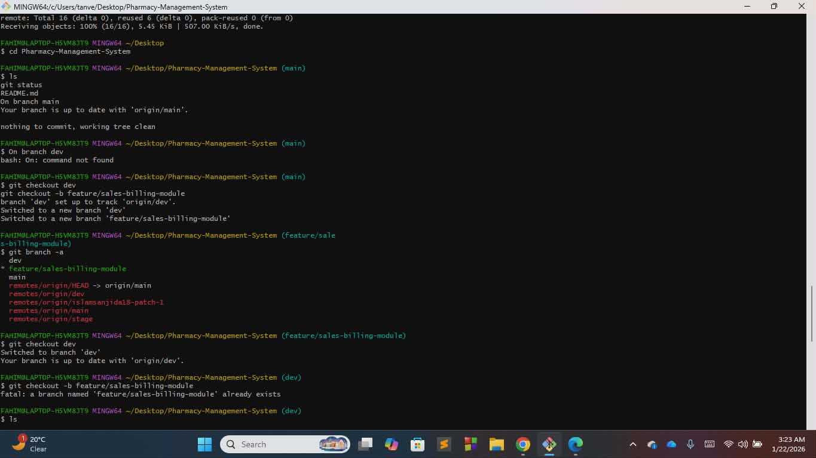

Asif-
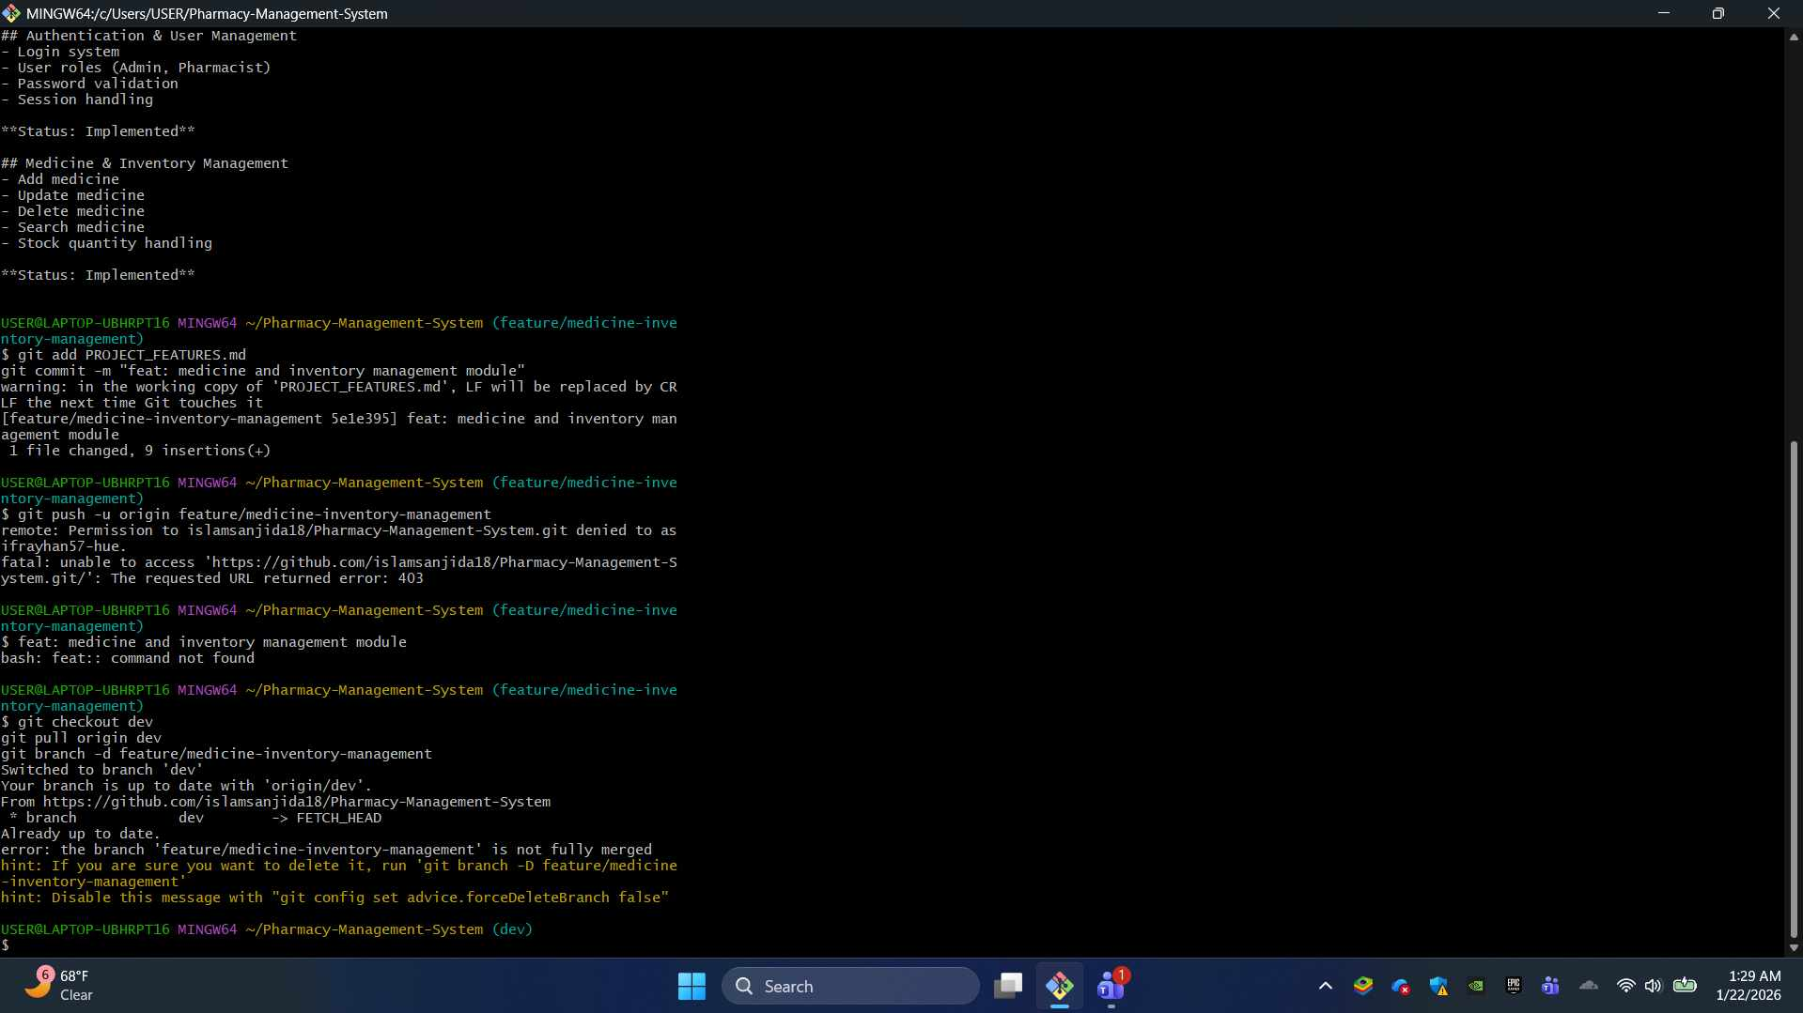

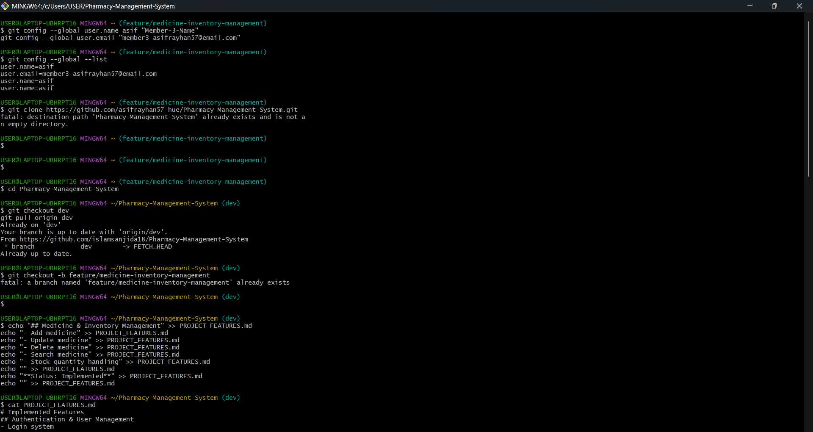

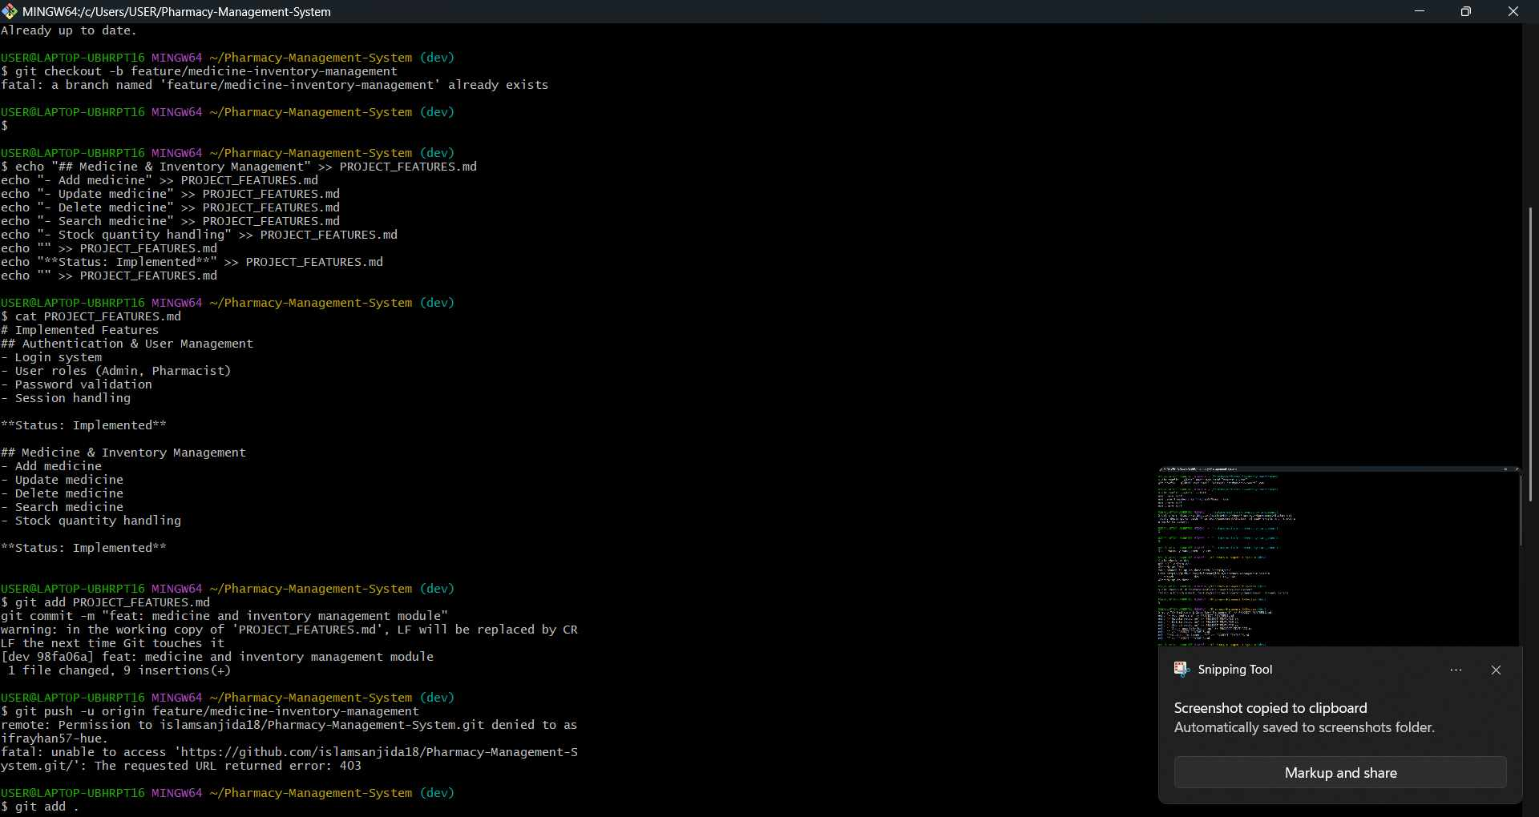

Sanjida-
Merging Fahid
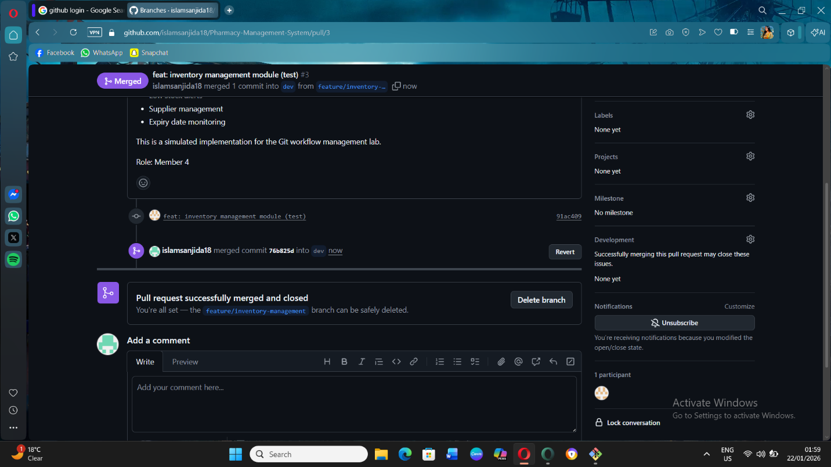

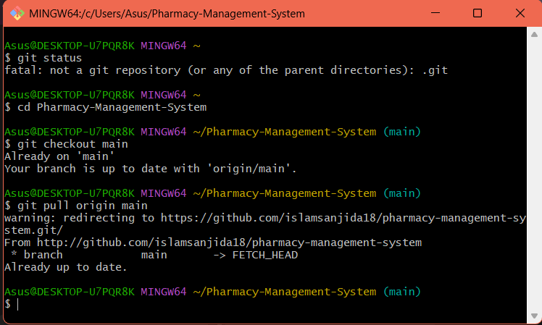

Merging Afraz
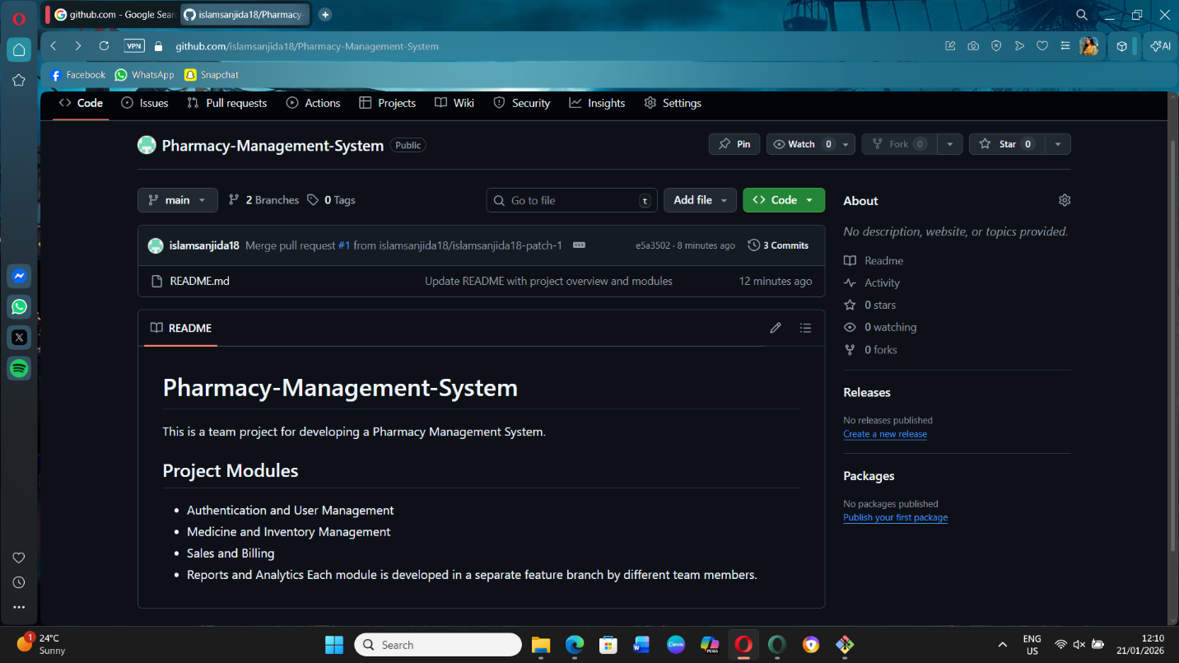
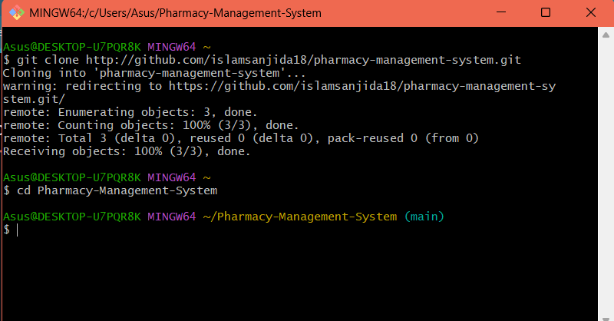
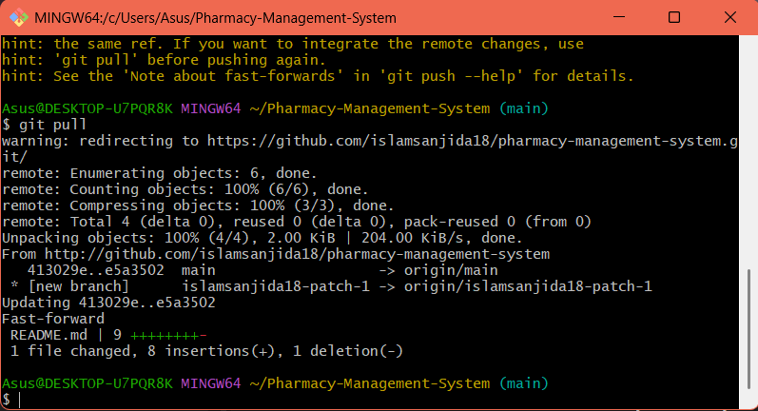

5. SOFTWARE TESTING

5.1 Testing Methods
- Unit Testing - Test individual components (Jest, Mocha)
- Integration Testing - Test module interactions
- Functional Testing - Validate all 18 features work correctly
- Security Testing - Penetration testing and vulnerability scans
- Performance Testing - Load testing with 500 concurrent users
- Usability Testing - With actual pharmacists and patients
- Compliance Testing - Validate against healthcare regulations
- UAT - User Acceptance Testing in pilot pharmacies

5.2 Sample Test Cases

Test Case 1: Medicine Search and Billing
- TC-ID: PMS_TC_001
- Title: Verify medicine search and POS billing
- Steps:
  - Login as Pharmacist
  - Search "Paracetamol 500mg"
  - Add to bill
  - Apply 5% discount
  - Generate invoice
- Expected: Bill generated with correct GST and discount

Test Case 2: Low Stock Alert
- TC-ID: PMS_TC_002
- Title: Verify automatic low stock notification
- Steps:
  - Set reorder level for "Amoxicillin" to 50 units
  - Simulate sales reducing stock to 45 units
  - Check notification system
- Expected: Alert sent to pharmacist and admin

Test Case 3: Prescription Validation
- TC-ID: PMS_TC_003
- Title: Verify prescription expiry and validity check
- Steps:
  - Upload prescription dated 30 days ago
  - Attempt to dispense controlled substance
  - Check system validation
- Expected: System rejects expired prescription

Test Case 4: Patient Allergy Check
- TC-ID: PMS_TC_004
- Title: Verify drug-allergy interaction alert
- Steps:
  - Patient profile shows "Penicillin allergy"
  - Pharmacist attempts to dispense Amoxicillin
  - Check system response
- Expected: System shows RED alert warning

Test Case 5: End-of-Day Report
- TC-ID: PMS_TC_005
- Title: Verify daily sales report generation
- Steps:
  - Process multiple sales transactions
  - Run "End of Day" report
  - Export to PDF
- Expected: Report shows correct totals, taxes, and payment methods

Project Name: Pharmacy Management System |  |  | Test Designed by: Kazi Sanjida Islam
Test Case ID: PMS_TC_001 |  |  | Test Designed Date: 21/01/26
Test Priority (Low, Medium, High): Medium |  |  | Test Executed By: Kazi Sanjida Islam
Module Name: Pharmacist Dashboard |  |  | Test Execution Date: - 22/01/26
Test Title: Verify medicine search and POS billing

Description: Verify if information about medicine and billing are up-to-date
Precondition: Must login as a pharmacist
Dependencies:
Test Steps | Test Data | Expected Results | Actual Results | Status (Pass/Fail)
1. Login as Pharmacist  2. Search  3. Paracetamol  4. 500mg"  5. Add to bill  6. Apply 5% discount  7. Generate invoice | Name: Sanjida Email: sanjidaislam18@gmail.com | Information Updated Successfully. | As expected | Pass

6. CONCLUSION

The MediCare+ Pharmacy Management System addresses critical gaps in Bangladesh's pharmaceutical sector by providing a comprehensive, secure, and user-friendly platform for pharmacy operations. By adopting the DSDM methodology, we ensure timely delivery of high-quality features that meet the specific needs of pharmacists, patients, and regulatory bodies.
The system's 18 core features cover all aspects of pharmacy management, from inventory control and prescription handling to patient engagement and regulatory compliance. With robust testing strategies and a focus on data security, MediCare+ ensures medication safety while improving operational efficiency.
This project has the potential to transform pharmacy operations across Bangladesh, reducing medication errors, minimizing wastage, improving patient care, and ensuring compliance with healthcare regulations. The scalable architecture allows for future enhancements, including telemedicine integration, AI-based drug interaction checks, and nationwide pharmacy network connectivity.
By bridging the gap between traditional pharmacy practices and digital healthcare solutions, MediCare+ represents a significant step forward in Bangladesh's healthcare digitalization journey.

